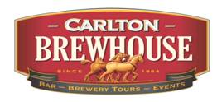

Date:               Wednesday, 9th December 2015

Event:              Christmas Function - Beer, Burgers & A Quiz @ Carlton Brewhouse

11.00               Tour of brewery

12.15               Tastings at the Bar

12.30               Lunch and Drink of choice for $25.00pp.

14.30               Finish

RSVP       by 30 November         Bronwyn Wilson [artscape@ssc.net.au](mailto:artscape@ssc.net.au)

