Customer Feedback
Please return the completed form via email (photo will do) to: membership@ptgaa.org.au
Please tick v one box for each question

Was your Tour Guide:

Waiting to meet you/on time

Friendly and courteous

Well organised

Did your Tour Guide:

Provide details of the tour:
Inclusions, timings, and other details

Check names and/or numbers of participants

Provide for any special needs

Speak clearly

Provide relevant, current information in an
Interesting manner

Include participants in conversation and
questions

Behave in a professional manner at all times
towards participants
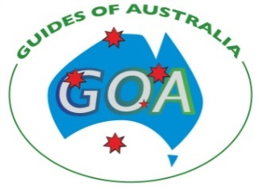

National Tour Guide Accreditation

Strongly Agree Neutral Disagree Strongly Not
Agree Disagree Applicable

Your Tour Guide’s Name:

…………………………………………………….

Did your Accredited Tour Guide, wear their ID Card with the Tour Guide accreditation logo?

YES NO

Day/Dates of tour:………………….……..…………

Additional comments:………………………………..

…………………………………………………………

…………………………………………………..…………..

…………………………………………………..…………..

…………………………………………………..…………..

……………………………………………………………….

If you are happy for your guide to use your feedback for promotion of services, please write your name, town and/or country below.

Name:…………………………………………….……

Town/Country:.……………………………….….……

Contact details:..………………………………….…..

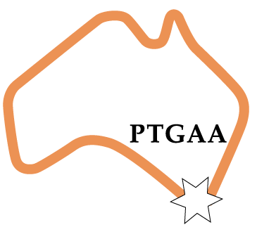

- Thank you for your feedback.

Contact Details:

Website:

www.ptgaa.com.au

Please send us a photo, or scan of your feedback to:

membership@ptgaa.org.au

OR

Post to:

The Professional Tour Guide Association
PTGAA, GPO Box 1252, Melbourne, Vic 3000

Australian Tour Guide Code of Conduct

An accredited Tour Guide will abide by the Australian Tour Guides’ Code of Conduct as set out below:

- To provide a professional service to visitors – professional in care and commitment, and in providing an objective understanding of the places visited – free from prejudice or propaganda.
- To ensure that every effort is made to present true and accurate facts and ensure that a clear distinction is made between truth and stories, legends, traditions or opinions.
- To act honestly, fairly and professionally in all dealings with those who engage the services of guides and with colleagues working in all aspects of tourism.
- Ensure that guided groups treat with respect the natural, cultural and heritage environments, and minimise impacts on these at all times.
- As representatives of Australia, I will welcome visitors and act in such a way as to bring credit to the country and promote it as a tourist destination.
- Regularly update and upgrade my guiding skills and knowledge, through training and professional development activities.
- Declare to customers any relevant personal commercial interests, including commissions, and never force visitor purchases or solicit tips.
- Be mindful at all times of duty of care and other health and safety issues.
- Provide all goods and services as presented in the tour itinerary and promotional material.
- Abide by all national, state and territory legislation governing the operation and conduct of tours, tour operators and tour guides.
- Be aware that GOA has a Complaints Handling Policy that covers issues that may be brought to our attention in relation to accredited tour guides.
- It is a requirement for accredited tour guides to establish a Complaints Handling procedure.

Customer Survey

Did your Tour Guide provide a
Quality experience?

National Tour Guide Accreditation

©GOA 2015

